CURRICULUM VITAE

SNG HAO JUN

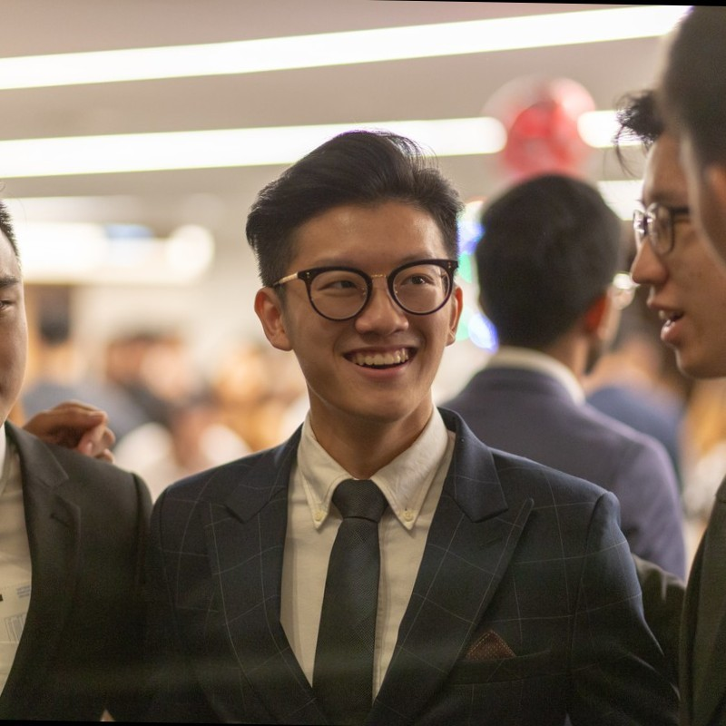

**Name**

Predictive Analytics Intern

iAPPS Pte Ltd

I am a proactive university undergraduate (4.5 GPA, Bachelor of Science in Business Analytics) currently attending National University of Singapore (NUS). In my first year, I participated in various hackathons to broaden my exposure and enrich my learning experience – such as Shopee’s Code League and BigByte’s Hackathon. In my second year, I manage to do an internship with Circles.Life as an analytics intern where I finally had the chance to put my theoretical knowledge from school to practical use as I worked with real and raw data.

Education

* **BSc in Business Analytics (Honors) in National University of Singapore 2018 – 2022**
* **GCE ‘A’ Levels in Pioneer Junior College 2014 - 2015**

Technical skillset

**R**: Competent

**Java**: Competent

**Python**: Competent

**React Native**: Competent

**SQL:** Competent

**Excel**: Competent

**Metabase:** Competent

**Adobe Analytics:** Competent

Working experience

* **Circles.Life Singapore (May 2020 – August 2020)**

Worked with Adobe Analytics to study trends to better understand consumers'

purchasing behavior/ site behavior.

Worked with Metabase (SQL) to analyse transactions data, churn rate and conversion

rate to contribute to more informed decision making processes in future.

Built Machine Learning Models in Python (Natural Language Processing - Sentiment

Analysis) to draw insights from textual feedback on consumers' attitudes towards

Circles.Life

Assisted in building a framework for the company that logs the journey taken by a

new product idea from start till end.

Adhoc analytics-related tasks using Excel

* **iAPPS Asia (October 2020 - Now)**

Build and deploy traditional Machine Learning models (SVM, Random Forest, Logistic

Regression, Time Series)

Perform text cleaning and text classification using NLP techniques

Build and deploy Neural Networks using Keras

Major achievements

* **Apollo 11 (Highest Level of Achievement) for Orbital 2019 – School of Computing, National University of Singapore**
* **Top in H2 Mathematics 2014, Pioneer Junior College**
* **Top in H2 Chemistry 2014, Pioneer Junior College**
* **Best in Knowledge 2017, Specialist Cadet Course (Professional Term), Singapore Armed Forces**
* **Best in Physical Fitness 2017, Specialist Cadet Course (Professional Term), Singapore Armed Forces**
* **Principal’s Honor Roll 2016**
* **NS Excellence Award 2019**